In the name of god



**Title**

PLT software document

**By**

Izadi, Mohammad Amin

**Supervisors**

Alemohammad, Seyede Nafiseh, Ph.D.

Geramifar, Parham, Ph.D.

February 2022

**1. Introduction**

PLT or Python Labeling Tool is a software for labeling the desired regions in PET/CT 3D images. PLT was developed using Python programming language and tkinter GUI[1] library. By simplifying the labeling process, the software helps oncologists to wrap their diagnosis in a comprehensible format for the computer. In addition to the general features of the viewer software, the tools developed for this kind of labeling process should also have characteristics desired by oncologists. In the rest of this article, we will describe the necessity of using PLT software and its structure.

**2. The necessity for PLT software development**

PLT software has been developed for labeling PET/CT 3D images. The purpose of labeling these images is to find tumor regions in body. PET images provide a metabolic map of the body that allows specialists to identify tumor regions. High intensity (uptake) regions in PET images show tumor parts of the body. There is no specific systematic format to record diagnosis, therefore, specialists often store their diagnosis manually. This problem leads to a lack of appropriate data for researchers in other interdisciplinary sciences, including artificial intelligence. This problem prevents the development of automatic detection methods on PET images. To solve this problem, AI researchers use public data available on the Internet, while this data is limited and does not meet much with the needs of modern medical imaging. PLT software allows specialists to easily select all voxels of their desired regions (tumor regions) on PET/CT images. To encourage specialists to use PLT software, the labeling process has been simplified. Before explaining the structure of PLT, we should provide an introduction to PET and CT images.

**3. PET and CT imaging standards**

As mentioned earlier, Positron Emission Tomography (PET) images provide a metabolic map of the body that can be used to identify tumor regions in the human body. To prepare this metabolic map, a radiopharmaceutical  should inject into the body as a tracer. Gamma rays are emitted and detected by gamma cameras to form a three-dimensional image. Commonly, the intensity of each pixel is called uptake (rate of radiopharmaceutical uptake) of that part of the body. In PET images, high uptake regions of the body are probably tumors. Since some regions of the body such as heart, brain, bladder and kidneys have high uptake due to their specific activities, High uptake should not be the only criterion for detecting tumor regions, so it is necessary for oncologist to examine high uptake regions to separate the normal tissues from the tumor. PET images do not provide adequate detail of the anatomical body tissues because of their specific imaging steps. Due to this feature, specialists use the fused PET and CT for their diagnosis. Computed tomography (CT) is an imaging standard in which CT scanners use a rotating X-ray tube and a row of detectors placed in the gantry to measure X-ray attenuations by different tissues inside the body. CT image can provide a more detailed view of body tissues to add precise anatomic information to PET images. So today PET commonly used in fusion with CT.

**4. Diagnosis of tumor regions**

Specialists examine PET/CT 3D image in all three modes of view (Axial, Coronal and Sagittal) slice by slice. To determine high uptake regions, a number of thresholding methods are defined. One of the most widely used thresholding methods is PERCIST. In this method, the threshold value is 1.5 times the average uptake of voxels in a sphere, which is drawn around the upper region of the liver. The radius of this sphere is usually considered to be 3 cm. With the exception of normal regions, the uptake of the remaining regions should be compared to the threshold value, and if the value was greater than the threshold, that region is suspected to be a tumor. Other conditions, such as shape, size, and texture of the tumor region, are checked to make sure that a region is a tumor or not. It should be noted that no thresholding method accurately determines suspicious regions of the body. Therefore, one region is a tumor for some other condition, although its uptake is less than the specified threshold.

**5. Python Labeling Tool (PLT) software**

Fig. 1 shows a schematic view of PLT software.

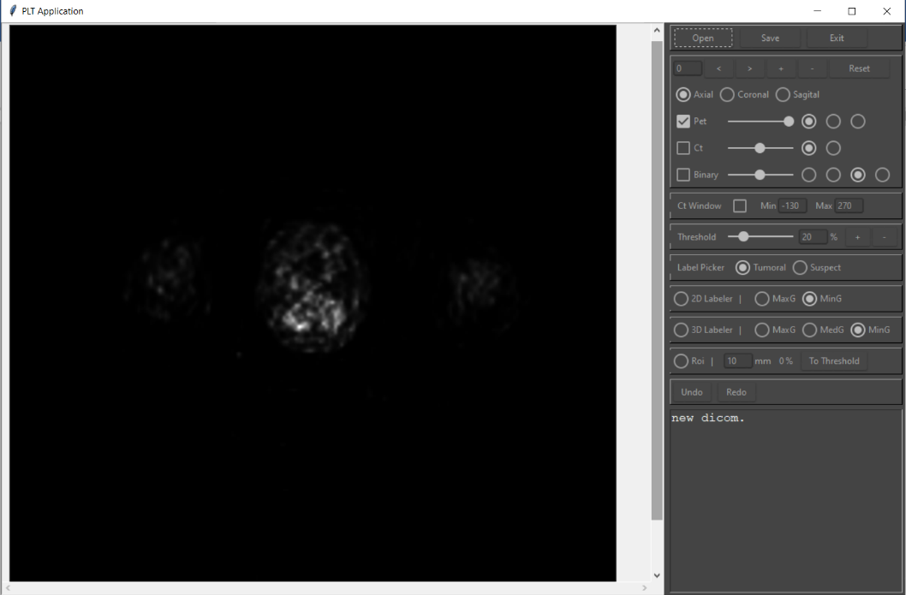

**Fig. 1: PLT software**

Once the software has opened, we use the open button to specify the path where PET and CT images are stored. The path where the user intends to save the output is also asked in this section. Once the images are fully loaded in the software, the tools on the right side of the software are activated for change.

The tools provided in this software are divided into two categories:

* Display tools
* Labeling tools

**5.1. Display tools**

In this section, the main tools for displaying images are provided. Fig. 2 shows these tools in PLT software.

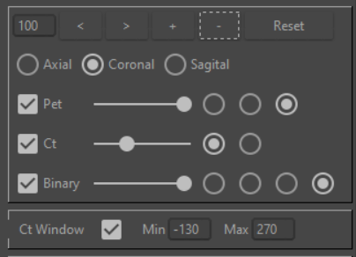

**Fig. 2: Display tools**

In addition to changing the slice number using **<** and **>** buttons, the user can also control the zoom range of the images using the **+** and **-** buttons. User also can change the number of slices by mouse scroll wheel. User can reset settings by clicking reset button. There are three image display modes (Axial, Coronal and Sagittal) for PET/CT images, which the user can click on to view the image in desired view. As shown in Fig. 1, after the images are loaded in software, the first slice of PET image will be displayed to user. The user can also view PET and CT fused image by activating the CT view. The possibility of changing the color and opacity of each PET and CT in the fused image is available for the user. The user also has the ability to change the CT display window. Fig. 3 shows a slice which some changes are applied to image by display tools.

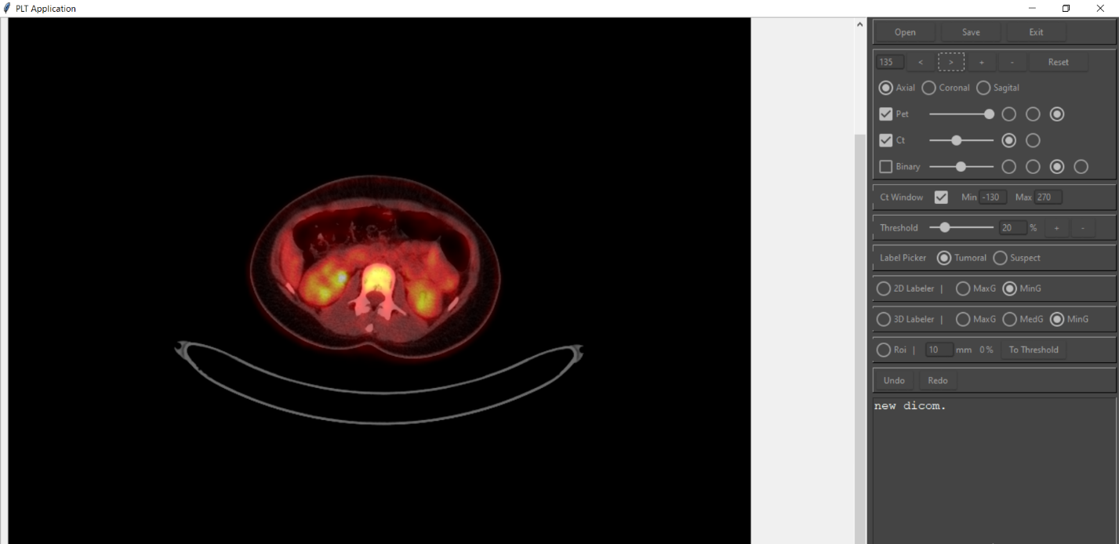

**Fig. 3: Change image view by display tools**

The desired tissues in the CT image are better seen by changing CT display window. If CT values are transferred to Hounsfield Units, then each tissue of the body can have a specific value. For example, fats are identified with -120, muscle with -40, and bones with -400. In this case, user can improve the display quality of the desired tissues by specifying a border on the CT image. To diagnose tumor regions, it is very important to see the soft tissue better, so the minimum and maximum values are set to -130 and +270, respectively. For this conversion, in the Hounsfield Units, we set the value of each voxel that its values is less than the lower limit of the window equal to -130 and each had a value greater than the upper limit of the window, + 270. CT images are usually not in the Hounsfield Units by default, and each voxel have gray value. Therefore, first of all we use Formula 1 to convert the selected window to the Hounsfield Units, then we change the images according to what mentioned before.

|  |  |
| --- | --- |
| (1) |  |

The values of the **rescale intercept** and **rescale slope** parameters are provided in the CT image metadata.

**5.2. Labeling tools**

Fig. 4 shows labeling tools in PLT software.

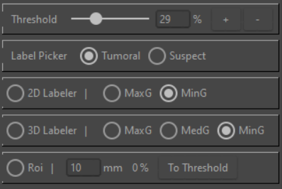

**Fig. 4: Labeling** **tools**

We mentioned earlier that regions that have high uptake are likely to be tumors. The oncologist examines various features to determine if a high uptake region is a tumor or not. These characteristics are related to the medical part of the diagnosis stage. In fact, PLT software provides features that user can use to view the image in a way that shows normal and tumor regions clearly. Also, after the tumor region has been identified, it is possible to label all its voxels with a simple method. Therefore, the tools in this section are divided into two categories:

* Tools for displaying regions with high uptake
* Tools for labeling regions

**5.2.1. Tools for displaying regions with high uptake**

The main way to identify high uptake regions in images is to use an appropriate threshold. Various thresholding methods have been introduced for this purpose, PERCIST is one of the most widely used thresholding methods. In PLT software, it is possible to use this thresholding method and in order to use it, the user must first activate the ROI feature and then specify a radius to draw the sphere. After making these settings, user can draw a sphere by clicking on the desired point in the image. The average uptake of all voxels located inside the sphere multiplied by 1.5 is determined as threshold. Although the use of the PERCIST method provides a good estimate for threshold, no thresholding method fully guarantees that all tumor regions in the image are above the suggested threshold. As mentioned earlier, the uptake of a region may be lower than a threshold, but that region is a tumor due to other conditions. Therefore, in PLT it is possible to set threshold manually. In this case, the user can choose a percentage between the minimum and maximum amount of uptake. After selecting a threshold, a binary image with same dimensions as PET will be created. In the binary image, voxels with a value equal to 1 have a higher uptake value than the threshold, and each voxel in the binary image has a value equal to 0, the uptake value of this voxel in PET is lower than threshold. By activating the Binary option, it is possible to view binary image fused with PET and CT. As before, the user can determine the opacity of binary image. Fig. 5 shows all three PET, CT and binary images together. Voxels with values equal to 1 (above the threshold) in the binary image are marked green in the image.

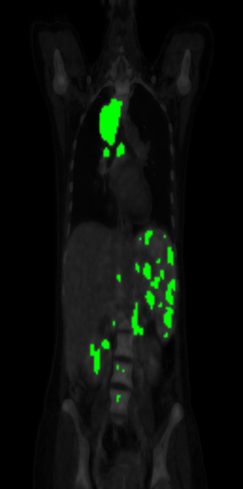

**Fig. 5: PET, CT and Binary fused image**

**5.2.2. Tools for labeling regions**

The user can click anywhere on the binary image to set or modify label. SRG (Seeded Region Growing) algorithm is then executed using the voxel selected by the user. An explanation of the SRG algorithm is included in the appendices. The output of this algorithm is voxels that are similar to the input voxel under conditions chosen by the user. In order to increase the accuracy of the labeling process, some adjustment options are provided to the user. In fact, these options set the second input (similarity criteria) of SRG algorithm. In SRG algorithm, the neighborhood limit and its 2D or 3D mode depends on the user's choice. If the user opts for 2D labeling, there are two options for setting the neighborhood limit:

1. Minimal mode: Voxels that are horizontally or vertically adjacent will be used in SRG.
2. Maximal mode: In addition to item 1, voxels that are adjacent to each other diagonally should also be included in the SRG.

If the user opts for 3D labeling, there are three options for setting the neighborhood limit:

1. Minimal mode: Voxels that are horizontally or vertically adjacent will be used in SRG.
2. Medium mode: In addition to item 1, voxels in a slice that are adjacent to each other diagonally should also be included in the SRG.
3. Maximal mode: In addition to item 1 and 2, voxels that are adjacent to each other diagonally in the z direction (different slices) should also be included in the SRG.

Obviously, if the user chooses to label image in a 2D way with a minimal neighborhood, the accuracy of labels will increase, but on the other hand, the speed of labeling process will decrease. The reverse is also true for 3D labeling with the maximum neighborhood.

A region will remain green if the user does not click on it, it will be red if the user labels it as a tumor, and if the user labels it suspicious, it will be orange. If the user raises the threshold, previously unlabeled voxels (green ones) will be gradually removed, and this is normal because their value is lower than the current threshold. Voxels that previously had one of the tumor or suspicious labels on them turn yellow if they are below the current threshold. User can modify the label by clicking on the yellow areas. This is especially useful for removing the margins of the tumor region and obtaining accurate tumors. If user decreases the threshold value from the threshold at which the labeling was performed, then green voxels appear in image and even surround areas that have already been labeled tumor or suspicious. In this way, user can enlarge the diagnostic region, unlike the previous case. User can save labels by clicking the save button after labeling is complete. Voxels labeled by user are saved as a json[2] file along with their labeling threshold. To correct the diagnosis, user can re-open image of a patient along with its label file in the software.

Fig. 6 shows a part of the process of working with PLT software. In image A, we see a slice of PET image in a plain mode. After activating Binary option and setting an appropriate threshold, image B will be obtained. If we select tumor label, 3D labeling method and medium mode for neighborhood limit and then if we click on a voxel in region at the top of image B, image C will be created. As you can see, the whole region is labeled with one click. The reason that smaller parts of the larger region are also labeled is due to our choices for labeling. For example, if the labeling was done with 2D labeling method, the two small areas would remain green. As the threshold increases, the margins of the region labeled as tumor also turn yellow, as their threshold is lower than the current threshold. Image D shows this state. By clicking on the yellow area, the tumor label can be removed to make the labeling process more accurate. image E shows the modified label.

**E D C B A**

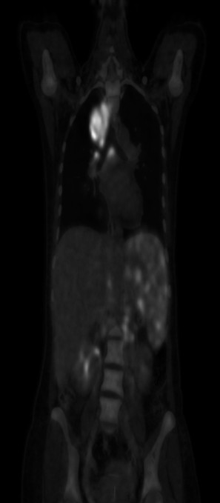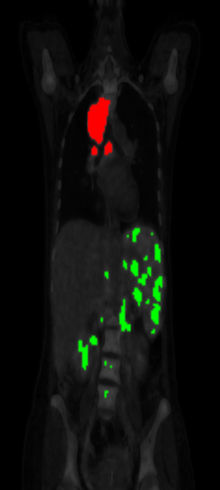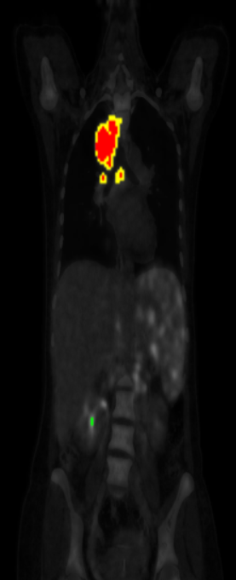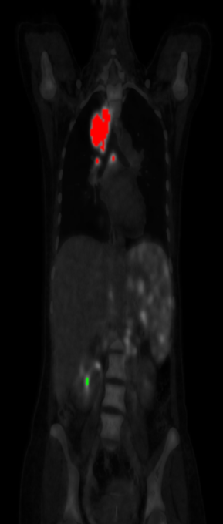

**Fig. 6: An example of labeling process**

In PLT software, there is a capability for undo and redo up to 5 steps to return the user to the previous state in case of a mistake in labeling process.

**6. Conclusion and future work**

Due to the simplification of the diagnostic process for specialists and other capabilities described for PLT software, it is possible to use this software as physician's assistant to systematically record the diagnosis. This software can help the growth of interdisciplinary sciences by faster producing labeled data. In the future, it is possible to develop software to cover other imaging standards as well as add other automated thresholding methods.

**Appendix**

**1. SRG algorithm**

Seeded Region Growing (SRG) is a method of image segmentation in which voxels of an image are grouped according to predetermined criteria. In this method, the user selects a voxel as seed and then preset similarity criteria determine whether the other voxels are in the same group with seed or not. In PLT software, the neighborhood and the equality of voxels uptake with seed uptake is a criterion of similarity. Each voxel must be in only one group. The steps of the algorithm are as follows:

1. Place the given voxel (seed) at the beginning of the Q queue and add it to set S.
2. Find the neighbors of the voxel that is at the beginning of the Q according to the defined neighborhood limit.
3. Add each of the neighbors to set S and the end of Q.
4. Continue steps 2 and 3 until the Q queue will be empty.

It should be noted that in the implemented version of the SRG algorithm in PLT software, the seed and the neighborhood criterion are received as input from the user.

1. Graphical user interface
2. JavaScript Object Notation